

QUENCH - A Smart Water Dispenser

Project Exhibition II

Submitted in partial fulfillment for the award of the degree of

Bachelor of Technology
In
ELECTRONICS AND COMMUNICATION ENGINEERING
(AI & CYBERNETICS)
Submitted to
VIT BHOPAL UNIVERSITY (M. P.)

Submitted by

KINSHUK PANDALA - 23BAC10026
MANTHAN SONTAKKE - 23BAC10034
RAADHESH BAJORIA - 23BAC10023

Under the Supervision of
DR. AMIT KUMAR SINGH

SCHOOL OF ELECTRICAL & ELECTRONICS ENGINEERING
VIT BHOPAL UNIVERSITY
BHOPAL (M.P.)-466114
April–2025
© VIT Bhopal University - 2025

VIT BHOPAL UNIVERSITY, Bhopal
SCHOOL OF ELECTRICAL & ELECTRONICS ENGINEERING

DECLARATION

I hereby declare that the Dissertation entitled “QUENCH - The Smart Water Dispenser” is my own work conducted under the supervision of Dr. Amit Kumar Singh, Assistant Professor Grade 1, SEEE at VIT Bhopal University, Bhopal.
I further declare that to the best of my knowledge this report does not contain any part of work that has been submitted for the award of any degree either in this university or in other university / Deemed University without proper citation.

Kinshuk Pandala 23BAC10026
Manthan Sontakke 23BAC10034
Raadhesh Bajoria 23BAC10023


VIT BHOPAL UNIVERSITY, Bhopal
SCHOOL OF ELECTRICAL & ELECTRONICS ENGINEERING
CERTIFICATE

This is to certify that the work embodied in this Project Exhibition - II report entitled “QUENCH - The Smart Water Dispenser” has been satisfactorily completed by Mr. Kinshuk Pandala, Manthan Sontakke, Raadhesh Bajoria Registration No. 23BAC10026, 23BAC10034, 23BAC10023 in the School of Electrical & Electronics Engineering of Electronics and communication engineering with specialization in AI and Cybernetics at VIT Bhopal University, Bhopal. This work is a bonafide piece of work, carried out under my/our guidance in the School of Electrical & Electronics Engineering for the partial fulfilment of the degree of Bachelor of Technology.

 | Dr. Amit Kumar Singh
 | Assistant Professor Grade -1
Forwarded by | Approved by
Dr. Soumitra K Nayak | Dr. M Suresh
Program Chair | Dean of SEEE

ACKNOWLEDGEMENT

In the first place I would like to record my gratitude to “Dr. Amit Kumar Singh” for his supervision, advice, and guidance from the very early stage of this thesis work as well as giving me extraordinary experiences throughout the work. Above all and the most needed, he provided me unflinching encouragement and support in various ways. His words have always inspired me to work in an efficient and comprehensive way. I would like to thank him for his constant encouragement that enabled me to grow as a person. His presence has definitely improved me as a human being.

I express my gratitude towards “Dr. M SURESH ”, Professor and Dean of School of Electrical and Electronics Engineering Department, VIT Bhopal University, Bhopal, for providing me all the help and permitted me to work in the laboratory with no time limits.

I shall ever remain indebted to “ Dr. T B Sridharan”, Pro Vice Chancellor, VIT Bhopal University, for providing me institutional and administrative facilities during my project work at VIT.

Raadhesh Bajoria 23BAC10023
Kinshuk Pandala 23BAC10026
Manthan Sontakke 23BAC10034

Abstract

QUENCH is an IoT-based, contactless water dispensing system designed for public and institutional use. It combines a hardware-controlled dispenser with a responsive web dashboard built for the admin or owner, enabling real-time monitoring and control. The system supports QR-based UPI payments and automates water flow using Raspberry Pi and ESP32. It features bottle detection, dynamic QR generation, and secure admin access via NFC. Firebase powers transaction logging and real-time data sync. QUENCH promotes efficient, cashless hydration with minimal manual intervention, offering a scalable solution for smart water stations.

List of Figures

Figure No | Caption Title | Page No
I.1 | Circuit Diagram
III.1 | Flowchart of ESP32 Logic
IV.1 | IoT Web Dashboard

List of Tables
Table No. | Caption / Title | Page No.
3.2.1 | Table of Hardware Components
3.3.1 | Table of Software Stack
4.2.1 | Table of Methodology
5.1.1 | Table of Successful Implementation
5.1.2 | Table of Partially Tested Features
5.1.3 | Table of Yet to be Implemented Features
6.1 | Table of Future Enhancement

List of Symbols & Abbreviations

API - Application Programming Interface
DB - Database
ESP32 - A popular microcontroller used in IoT applications
Firebase - A platform for building web and mobile applications
GSM - Global System for Mobile Communications
IoT - Internet of Things
LCD - Liquid Crystal Display
NFC - Near Field Communication
Pi - Raspberry Pi (a small computer used in the system)
QR - Quick Response (Code)
REST - Representational State Transfer
RFID - Radio Frequency Identification
TFT - Thin-Film Transistor (related to the LCD screen)
UPI - Unified Payments Interface

 | Table of Contents
 | Front Page | ii
 | Candidate’s Declaration | iii
 | Certificate | iv
 | Acknowledgement | v
 | Executive Summary | vi
 | List of Figures | vii
 | List of Tables | viii
 | List of Symbols & Abbreviations | ix
CHAPTER NO | CONTENTS
1 | INTRODUCTION
 | 1.1 Motivation
 | 1.2 Problem Statement
 | 1.3 Objectives
 | 1.4 Scope of the Project
 | 1.5 Methodology Overview
2 | LITERATURE REVIEW
2.1 Existing Solutions
2.2 Review Of Related Research Papers
2.3 Identified Gaps
3 | SYSTEM DESIGN AND IMPLEMENTATION

3.1 System Architecture
3.2 Hardware Components
3.3 Software Stack
3.4 Implementation Highlights

4 | PROBLEM FORMULATION AND PROPOSED METHODOLOGY
4.1 Problem Statement
4.2 Proposed Methodology

5 | RESULTS AND DISCUSSION  5.1 RESULTS  5.1.1 Successfully Implemented Features  5.1.2 In Progress Features  5.1.3 Features Yet To Be Implemented  5.2 DISCUSSION
6 | CONCLUSION AND FUTURE SCOPE
 | REFERENCES
 | APPENDICES

INTRODUCTION

1.1 MOTIVATION
Water sustainability is one of the most pressing challenges in today’s urban and campus environments. The increasing demand for drinking water in semi-public spaces like colleges, railway stations, and offices often leads to wastage due to manual operation, overuse, and lack of monitoring. With digital transformation and environmental awareness on the rise, there is a growing need for intelligent systems that encourage responsible water usage. QUENCH was conceptualized to address these concerns by providing an IoT-powered, smart, and contactless solution that makes hydration more efficient, cashless, and eco-conscious.

1.2 PROBLEM STATEMENT
Manual water dispensers in public environments lead to inefficient usage, hygiene issues, and lack of accountability. Additionally, traditional coin or token-based machines lack integration with digital payment systems and don’t provide system insights or analytics. There's a need for an affordable, scalable, and smart water dispensing system that addresses these inefficiencies.

1.3 OBJECTIVES
- Promote sustainable and minimal water usage in public and semi-public areas.
- Implement contactless, hygienic dispensing using real-time bottle detection.
- Introduce UPI-based QR payments for a cashless experience.
- Enable secure admin control and remote monitoring via an IoT dashboard.
- Log transactions and device status using a scalable cloud backend.

1.4 SCOPE OF THE PROJECT
This project represents a working prototype rather than a fully deployed product. While some core features such as bottle detection, NFC-based admin login, real-time dashboard sync, and cloud-based data logging are fully functional, others—like real-time UPI payment verification and variable flow rates—are currently under development or planned for future iterations. QUENCH lays the groundwork for smart hydration stations aimed at promoting water sustainability and smart city integration.

1.5 METHODOLOGY OVERVIEW
- Use of an ultrasonic sensor on ESP32 for detecting the presence of a bottle.
- QR code generation for UPI payments, displayed on LCD via ESP32.
- Data sync to Firebase for logging user actions and system health.
- Raspberry Pi hosts a Flask API and web-based admin dashboard.
- NFC module for admin login and access control.
- Visualization using Chart.js and real-time dashboard updates.
- Real-time payment verification currently under research and not yet implemented.

LITERATURE REVIEW

2.1 EXISTING SOLUTIONS
Several smart water dispensing systems exist, primarily in commercial or institutional setups. However, most are either closed-source, require proprietary hardware, or lack integration with cashless payment systems. Common features include timed dispensing mechanisms, coin-operated systems, or basic sensor-based triggers. Some use GSM modules for remote monitoring, but few offer scalable IoT dashboards or integrate with real-time cloud services.
Commercial water ATMs installed in rural or urban areas often use RFID or coin-based access and operate in isolation, without real-time administrative control. Moreover, many lack efficient water-saving logic, resulting in unnecessary wastage.

2.2 REVIEW OF RELATED RESEARCH PAPERS
[1] Mahor et al. (2010) – Developed a basic automatic water dispenser using solenoid valves and timers. It lacked real-time monitoring and did not support any form of remote or digital control.
[2] Sharma et al. (2018) – Proposed a GSM-based water level monitoring system that sent SMS alerts for threshold levels but did not include user interaction or payment handling.
[3] Singh et al. (2019) – Integrated QR code payment in vending machines. While innovative, the system was expensive and lacked flexibility for open-source or low-budget implementations.
[4] Kumar et al. (2021) – Introduced an IoT-enabled irrigation and water usage system with cloud integration. Although promising, it was designed for agricultural applications and not adaptable to public drinking water dispensing.
[5] Kavitha et al. (2022) – Explored smart kiosks for water using RFID cards. However, these lacked flexibility in payment methods and did not utilize live cloud dashboards for admin monitoring.

2.3 IDENTIFIED GAPS
- Lack of Real-Time Cloud Integration: Most systems are offline or operate in a closed loop without a scalable dashboard.
- Absence of Modern Payment Options: QR-based UPI payment integration is not widely implemented, limiting convenience.
- Minimal Emphasis on Sustainability: Few systems actively control water wastage through bottle detection or conditional dispensing.
- High Cost and Proprietary Systems: Most available solutions are either too expensive or non-customizable.
- Limited Admin Control: Remote access, analytics, and secure admin login are often missing.

SYSTEM DESIGN AND IMPLEMENTATION

3.1 SYSTEM ARCHITECTURE
The QUENCH system is structured around a modular IoT-based architecture, combining both hardware and software components to deliver a smart, scalable, and semi-autonomous water dispensing solution.
Overview:
- Raspberry Pi 4 serves as the central node, acting as both the server and host for the admin dashboard and API backend (built using Flask)
- ESP32 microcontroller handles hardware interfacing — including bottle detection via an ultrasonic sensor, QR code generation, and servo motor control.
- Firebase Realtime Database is used to log transactions, track sensor data, and enable live sync with the admin dashboard.
Note: Some features, such as real-time payment verification and dynamic flow control, are still under active development. However, the system is designed to accommodate these extensions with minimal restructuring.
Architecture Flow:
- Bottle detection is triggered via ultrasonic sensors.
- ESP32 displays a unique UPI QR code (concept).
- Payment confirmation (to be implemented) leads to servo activation and water dispensing.
- Transaction and event data are pushed to Firebase.
- Admin dashboard (web UI) reflects real-time changes and device health.

3.2 HARDWARE COMPONENTS
Component | Role/Function | Status
ESP32 | Microcontroller for sensor and motor control | Implemented
Raspberry Pi 4 | Local server & dashboard host | Implemented
Ultrasonic Sensor | Bottle presence detection | Implemented
Servo Motor | Controls the dispensing valve | Implemented
TFT2.8” LCD | Display system messages and QR instructions | Implemented
NFC Module | Enables secure admin login | Implemented
Power Module | Provides power to the entire setup | Implemented

3.2.1 Table of Hardware Components

3.3 SOFTWARE STACK
Layer | Tools/Tech Used | Description
Frontend | HTML, CSS, JavaScript | Responsive dashboard for monitoring and admin login
Backend API | Python (Flask) | REST API for logging and interacting with Firebase
Database | Firebase Realtime DB | Syncs sensor data, system logs, and transaction info
Analytics | Chart.js | Dynamic charts and visual feedback for administrators
Device Code | Arduino-style C++ (ESP32) | Controls sensor readings, motor actions, QR generation

3.3.1 Table of Software Stack

3.4 IMPLEMENTATION HIGHLIGHTS
- Real-time Bottle Detection: The ultrasonic sensor accurately detects the presence of a water container beneath the outlet.
- NFC Admin Access: Admin login is secured via NFC tags, preventing unauthorized control.
- QR Code Display (Prototype): Static/dynamic QR codes can be shown on the LCD; real-time verification is a future enhancement.

PROBLEM FORMULATION AND METHODOLOGY

4.1 Problem Statement
Water wastage and inefficient manual water dispensing practices continue to persist in semi-public and institutional environments. These issues are exacerbated by the absence of user accountability, lack of data-driven monitoring, and limited access to automated, sustainable systems.
Design and develop an IoT-based smart water dispensing system that:
- Encourages water conservation through automation.
- Enables seamless cashless transactions using QR codes.
- Provides real-time data tracking and administrative control.
- Operates efficiently with minimal human intervention

4.2 Proposed Methodology
The methodology for developing QUENCH involves an interdisciplinary approach that includes embedded systems, IoT communication, cloud-based storage, and web technologies. The system is designed to scale while maintaining affordability and modularity.
Stepwise Flow of the Proposed System
Step | Description | Status
1 | Bottle detection using an ultrasonic sensor to trigger readiness for dispensing. | Implemented
2 | QR code generation linked to a virtual UPI handle, displayed on the LCD. | Prototype
3 | Payment verification via webhook or listener (planned). | In Progress
4 | Servo motor control to allow water flow upon successful detection/payment. | Implemented
5 | Logging the transaction and device status to Firebase Realtime Database. | Implemented
6 | Dashboard update to reflect live statistics and operational status using Chart.js. | Implemented
7 | Admin authentication using NFC for secure access to device settings. | Implemented
4.2.1 Table of Methodology
Methodological Considerations
- Hardware-Software Integration: Carefully planned GPIO management between ESP32 and Pi ensures minimal conflicts and efficient task allocation.
- Data Handling: Firebase is used for real-time operations; offline fallbacks can be considered for reliability.
- Sustainability by Design: Dispensing is conditional, only when a bottle is detected and payment is (conceptually) verified, directly minimizing water misuse.
- Scalability: The architecture allows future upgrades such as cloud hosting, remote updates, solar integration, and multi-node deployments.

5. RESULTS AND DISCUSSION

5.1 Results
The QUENCH prototype was developed and tested in a lab-controlled environment. While not all features have been fully implemented, several core components are functional and demonstrate the viability of the system. The results are categorized into three segments: successfully implemented features, partially tested prototypes, and pending features.
A. Successfully Implemented Features
Feature | Outcome
Ultrasonic Bottle Detection | Reliably detects presence of a bottle and triggers the dispensing sequence.
Servo Motor Actuation | Controlled by ESP32, opens/closes the valve based on bottle detection logic.
Firebase Logging | Captures time-stamped events like detection, NFC login, and mock transactions.
Real-time Dashboard | Reflects live system stats and logs using Chart.js visualizations.
NFC-based Admin Access | Secure login system for authorized users to access and control the system.
5.1.1 Table of Successful Implementations
B. Partially Tested / In-Progress Features
Feature | Status | Notes
QR Code UPI Payment | Prototype | QR generation is functional; a backend listener for confirmation is under development.
System Error Logging | Partial | Some basic error conditions are logged; needs more robust fail-safe systems.
5.1.2 Table of Partially Tested Features

C. Features Yet to Be Implemented
Feature | Notes
Real-time Payment Confirmation | Requires server-side webhook or polling service for dynamic payment feedback.
Variable Flow Dispensing | Conceptual stage; will require volume-based sensor integration and servo adjustments.
Flow Rate Monitoring | Excluded from prototype to maintain hardware simplicity. May be added in future.
5.1.3 Table of Yet to Be Implemented Features

5.2 Discussion
The QUENCH project successfully demonstrates that a low-cost, modular smart water dispensing system is feasible with off-the-shelf IoT components. Some of the intended features are still being developed or tested, but the current working system delivers core functionality aligned with the project's sustainability goals.
Sustainability Impact
The system reduces water waste by dispensing only when a bottle is detected and a (planned) payment is confirmed. Even at its current stage, QUENCH provides a more conscious alternative to manual water taps or free-flow dispensers commonly seen in public spaces.
Key Technical Insights
- Firebase: Chosen for its real-time syncing capabilities, low-latency performance, and ESP32 support.
- ESP32 & Raspberry Pi Pairing: The decision to split sensor control and dashboard hosting between the two devices allows parallel development and efficient resource use.
- Open Architecture: The system remains modular and extensible — making it adaptable for future integrations like solar power, multiple dispensing outlets, or cloud-based monitoring.

CONCLUSION AND FUTURE SCOPE
The development of QUENCH: An IoT-Based Smart Water Dispensing System has laid a strong foundation toward sustainable and tech-driven public utility solutions. Although several features are still under development, the functional prototype has proven that it is possible to:
- Detect the presence of a bottle and trigger a controlled water dispensing mechanism.
- Log key system activities in real time using Firebase.
- Display analytics and data visually on a responsive web dashboard.
- Provide secure admin access through NFC authentication.
The modular architecture and component selection (ESP32 + Raspberry Pi) ensure that future enhancements can be integrated without overhauling the existing framework.
Above all, QUENCH reaffirms the importance of water sustainability by ensuring water is dispensed only when needed, reducing manual misuse, and minimizing wastage — especially in semi-public environments like campuses, transport hubs, and commercial spaces.
While the current prototype covers basic functionality, several planned enhancements will transform QUENCH into a fully autonomous and scalable smart water station. These include:
Enhancement | Description
Real-time Payment Confirmation | Implement a webhook or polling method to verify UPI payments dynamically before dispensing.
Volume Selection by User | Offer options like 250ml, 500ml, or 1L using UI buttons and volume presets via servo control.
Card / NFC Payments | Expand cashless transaction methods to include NFC-based smart cards or ID badges.
Flow Rate Monitoring | Introduce water flow sensors for accurate volume tracking and leakage detection.
Multi-device Dashboard Support | Extend admin dashboard to control and monitor multiple QUENCH units from a single interface.
Mobile Notification Alerts | Alert admins on system faults, low water levels, or tampering via SMS/email push.
Public User Feedback Interface | Allow users to rate experience or report issues using a QR-linked form.
6.1 Table of Future Enhancements
REFERENCES

[1] Bhuiya, Aritra, Aditya Mukherjee, and Ranjit Kumar Barai. "Development of wi-fi communication module for atmega microcontroller based mobile robot for cooperative autonomous navigation." 2017 IEEE Calcutta Conference (CALCON). IEEE, 2017.
[2] Chougule, Amruta Rajendra, and K. Suganthi. "IoT based smart car monitoring system." 2018 Tenth International Conference on Advanced Computing (ICoAC). IEEE, 2018.
[3] Patel, Shreyaskumar. "Optimizing Wiring Harness Minimization through Integration of Internet of Vehicles (IOV) and Internet of Things (IoT) with ESP-32 Module: A Schematic Circuit Approach." (2023).
[4] Mahor, A., Verma, R., and Singh, N. "Design and development of an automatic water dispenser using solenoid valves and timers." International Journal of Emerging Technologies, vol. 5, no. 2, pp. 45–49, 2010.
[5] Sharma, M., Patel, R., and Dube, A. "GSM-based water level monitoring and alert system." Journal of Embedded Systems and Applications, vol. 9, no. 3, pp. 112–117, 2018.
[6] Singh, V., Kumar, S., and Rao, P. "QR code enabled vending machines for water dispensing." 2019 International Conference on Smart Systems and IoT, pp. 115–120. IEEE, 2019.
[7] Kumar, P., Deshmukh, M., and Kaur, G. "IoT-based irrigation and water usage system with cloud monitoring." Journal of Agricultural Innovations, vol. 12, no. 1, pp. 30–36, 2021.
[8] Kavitha, S., Narayanan, D., and Raj, A. "Smart water kiosks with RFID-enabled access and cloud integration." International Journal of Smart Technology, vol. 8, no. 4, pp. 221–227, 2022.

APPENDICES

Appendix I
Circuit Diagram

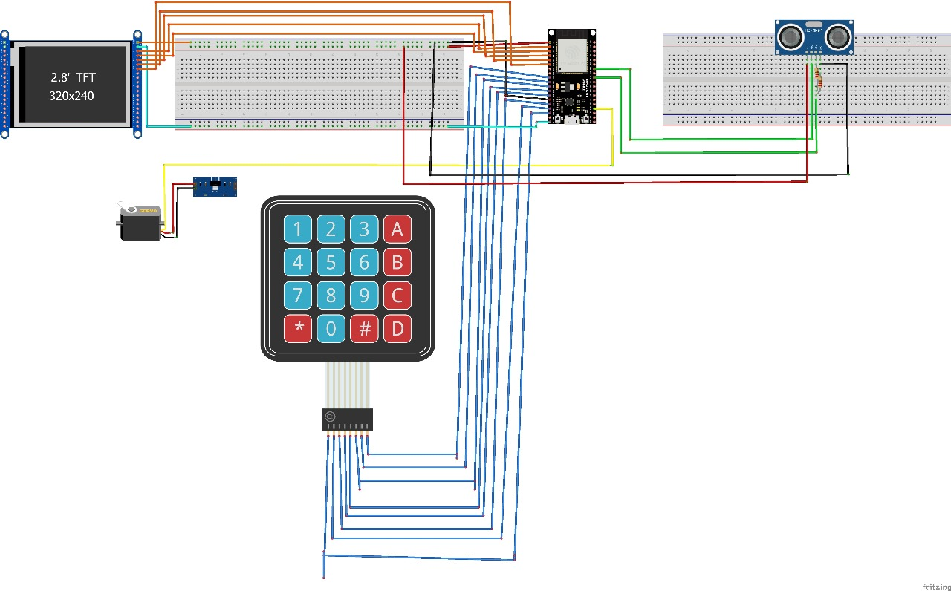

Figure I.1 Circuit Diagram

Appendix II
Source Code

#include <SPI.h>
#include <Adafruit_GFX.h>
#include <Adafruit_ILI9341.h>
#include <Keypad.h>
#include <ESP32Servo.h>
#include "qrcodegen.h"

// Define TFT Display Pins
#define TFT_CS 15
#define TFT_RST 4
#define TFT_DC 2
// Create TFT display object
Adafruit_ILI9341 tft = Adafruit_ILI9341(TFT_CS, TFT_DC, TFT_RST);
// Define 4x4 Keypad
const byte ROWS = 4;
const byte COLS = 4;
char keys[ROWS][COLS] = {
{'1', '2', '3', 'A'},
{'4', '5', '6', 'B'},
{'7', '8', '9', 'C'},
{'*', '0', '#', 'D'}
};
byte rowPins[ROWS] = {13, 12, 14, 27};
byte colPins[COLS] = {26, 25, 19, 21};
// Create Keypad object
Keypad keypad = Keypad(makeKeymap(keys), rowPins, colPins, ROWS, COLS);
// HC-SR04 Ultrasonic Sensor Pins
#define TRIG_PIN 22
#define ECHO_PIN 16
// Servo Motor Pin
#define SERVO_PIN 5
Servo tapServo;
// Flow rate calculation - 100ml per second flow rate
const float ML_PER_SECOND = 10.0; // 100ml flows in 1 second
// QR Code Buffers
uint8_t qrcodeData[qrcodegen_BUFFER_LEN_MAX];
uint8_t tempBuffer[qrcodegen_BUFFER_LEN_MAX];
// Store User Inputs
String inputML = "";
String inputMoney = "";
bool showingQR = false;
bool paymentVerified = false;
bool cupDetected = false;
int countdownTimer = 0;
unsigned long lastTimerUpdate = 0;
bool dispensingComplete = false;
unsigned long dispensingStartTime = 0;
// Screen state
enum ScreenState {
WELCOME_SCREEN,
ML_INPUT_SCREEN,
CALCULATE_AMOUNT_SCREEN,
QR_CODE_SCREEN,
PAYMENT_VERIFIED_SCREEN,
CUP_DETECTION_SCREEN,
DISPENSING_SCREEN,
THANK_YOU_SCREEN
};
ScreenState currentScreen = WELCOME_SCREEN;
// Conversion rate: 1000ml = 20 Rs (new rate)
const float ML_TO_RS_RATE = 0.02; // 20 Rs / 1000 ml = 0.02 Rs per ml
const int MAX_DISPENSING_ML = 1500; // Maximum 1.5L limit
// Cup detection parameters
const float CUP_DETECTION_DISTANCE = 10.0; // cm - if object detected within this distance, cup is present
const int CUP_DETECTION_TIMEOUT = 15000; // ms - timeout for cup detection (15 seconds)
unsigned long cupDetectionStartTime = 0;
// Function to measure distance using HC-SR04
float measureDistance() {
// Clear the trigger pin
digitalWrite(TRIG_PIN, LOW);
delayMicroseconds(2);
// Set trigger pin HIGH for 10 microseconds
digitalWrite(TRIG_PIN, HIGH);
delayMicroseconds(10);
digitalWrite(TRIG_PIN, LOW);

// Read the echo pin, returns the sound wave travel time in microseconds
long duration = pulseIn(ECHO_PIN, HIGH);
// Calculate distance in centimeters
// Speed of sound is 343 m/s = 0.0343 cm/µs
// Time is round trip so we divide by 2
float distance = duration * 0.0343 / 2;
return distance;
}
// Function to detect cup presence
bool detectCup() {
float distance = measureDistance();
Serial.print("Distance: ");
Serial.print(distance);
Serial.println(" cm");
return (distance < CUP_DETECTION_DISTANCE && distance > 0);
}
// Function to control tap servo
void controlTap(bool openTap) {
if (openTap) {
// Open tap (position depends on servo orientation)
tapServo.write(90); // Adjust value as needed for your setup
} else {
// Close tap
tapServo.write(0); // Adjust value as needed for your setup
}
}

// Function to Generate QR Code
void generateQRCode(String data) {
tft.fillScreen(ILI9341_BLACK);
tft.setCursor(40, 40);
tft.setTextSize(2);
tft.setTextColor(ILI9341_WHITE);
tft.println("Generating QR...");
Serial.println("Generating QR Code for: " + data);
bool success = qrcodegen_encodeText(
data.c_str(), tempBuffer, qrcodeData,
qrcodegen_Ecc_LOW, qrcodegen_VERSION_MIN, qrcodegen_VERSION_MAX,
qrcodegen_Mask_AUTO, true
);
if (!success) {
Serial.println("QR Code Generation Failed!");
tft.setCursor(50, 80);
tft.setTextColor(ILI9341_RED);
tft.println("QR Failed!");
return;
}
Serial.println("QR Code Successfully Generated!");
// Display QR Code
int qrSize = qrcodegen_getSize(qrcodeData);
int scale = 5;
int xOffset = (tft.width() - (qrSize * scale)) / 2;
int yOffset = 50;
tft.fillScreen(ILI9341_BLACK);
// Show what's being purchased
tft.setCursor(10, 10);
tft.setTextSize(2);
tft.setTextColor(ILI9341_WHITE);
tft.print("ML: ");
tft.println(inputML);
tft.setCursor(10, 30);
tft.print("Rs: ");
tft.println(inputMoney);
for (int y = 0; y < qrSize; y++) {
for (int x = 0; x < qrSize; x++) {
if (qrcodegen_getModule(qrcodeData, x, y)) {
tft.fillRect(xOffset + x * scale, yOffset + y * scale, scale, scale, ILI9341_WHITE);
}
}
}
tft.setCursor(10, 220);
tft.setTextSize(1);
tft.setTextColor(ILI9341_YELLOW);
tft.println("Press D to verify payment");
showingQR = true;
currentScreen = QR_CODE_SCREEN;
}
void showWelcomeScreen() {
tft.fillScreen(ILI9341_BLACK);
// Center-aligned WELCOME text only
int welcomeWidth = 126; // Approximate width of "WELCOME" text with font size 3
tft.setCursor((tft.width() - welcomeWidth) / 2, 40);
tft.setTextSize(3);
tft.setTextColor(ILI9341_CYAN);
tft.println("WELCOME");
// Left-aligned options (not centered)
tft.setCursor(30, 100);
tft.setTextSize(2);
tft.setTextColor(ILI9341_WHITE);
tft.println("A = Request ML");
tft.setCursor(30, 130);
tft.println("B = Calculate Amount");
// Left-aligned info text
tft.setCursor(30, 190);
tft.setTextSize(1);
tft.setTextColor(ILI9341_YELLOW);
tft.println("Max limit: 1500 ML (1.5L)");
tft.setCursor(30, 210);
tft.println("Rate: Rs 20 per 1000 ML");
currentScreen = WELCOME_SCREEN;
dispensingComplete = false;
}
void showMLInputScreen() {
tft.fillScreen(ILI9341_BLACK);
tft.setCursor(20, 30);
tft.setTextSize(2);
tft.setTextColor(ILI9341_CYAN);

tft.println("REQUEST ML AMOUNT");
tft.setCursor(20, 70);
tft.setTextColor(ILI9341_WHITE);
tft.println("Enter ML: " + inputML);
if (inputML.length() > 0) {
int ml = inputML.toInt();
if (ml > MAX_DISPENSING_ML) {
tft.setCursor(20, 100);
tft.setTextColor(ILI9341_RED);
tft.println("Exceeds 1.5L limit!");
tft.setTextColor(ILI9341_WHITE);
}
}

tft.setCursor(20, 140);
tft.setTextSize(1);
tft.println("* = Clear, # = Backspace");
tft.setCursor(20, 160);
tft.println("A = Back to Welcome");
tft.setCursor(20, 180);
tft.println("C = Generate QR");
currentScreen = ML_INPUT_SCREEN;
}
void showCalculateAmountScreen() {
tft.fillScreen(ILI9341_BLACK);
tft.setCursor(20, 30);
tft.setTextSize(2);
tft.setTextColor(ILI9341_CYAN);
tft.println("CALCULATE AMOUNT");
tft.setCursor(20, 70);
tft.setTextColor(ILI9341_WHITE);
tft.println("Enter ML: " + inputML);
// Calculate and show price if ML is entered
if (inputML.length() > 0) {
calculatePrice();
tft.setCursor(20, 110);
tft.println("Price: Rs " + inputMoney);
int ml = inputML.toInt();
if (ml > MAX_DISPENSING_ML) {
tft.setCursor(20, 140);
tft.setTextColor(ILI9341_RED);
tft.println("Exceeds 1.5L limit!");
tft.setTextColor(ILI9341_WHITE);
}
}

tft.setCursor(20, 180);
tft.setTextSize(1);
tft.println("* = Clear, # = Backspace");
tft.setCursor(20, 200);
tft.println("A = Back to Welcome");
tft.setCursor(20, 220);
tft.println("C = Generate QR");

currentScreen = CALCULATE_AMOUNT_SCREEN;
}
void calculatePrice() {
if (inputML.length() > 0) {
float ml = inputML.toFloat();
float price = ml * ML_TO_RS_RATE;
// Round to 2 decimal places
price = round(price * 100) / 100.0;
inputMoney = String(price);
} else {
inputMoney = "";
}
}
void showPaymentVerified() {
tft.fillScreen(ILI9341_BLACK);
tft.setCursor(40, 80);
tft.setTextSize(3);
tft.setTextColor(ILI9341_GREEN);
tft.println("PAYMENT");
tft.setCursor(40, 120);
tft.println("VERIFIED");

tft.setCursor(20, 180);
tft.setTextSize(2);
tft.setTextColor(ILI9341_WHITE);
tft.println("Looking for cup...");

delay(2000); // Show verification message for 2 seconds

currentScreen = PAYMENT_VERIFIED_SCREEN;
startCupDetection();
}
void startCupDetection() {
tft.fillScreen(ILI9341_BLACK);
tft.setCursor(20, 30);
tft.setTextSize(2);
tft.setTextColor(ILI9341_CYAN);
tft.println("PLACE YOUR CUP");
tft.setCursor(40, 80);
tft.setTextSize(2);
tft.println("Waiting for cup");
tft.setCursor(40, 120);
tft.setTextColor(ILI9341_WHITE);
tft.println("detection...");
tft.setCursor(20, 200);
tft.setTextSize(1);
tft.setTextColor(ILI9341_YELLOW);
tft.println("Press any key to cancel");
currentScreen = CUP_DETECTION_SCREEN;
cupDetectionStartTime = millis();
}
void startDispensingWater() {
// Convert ML to dispensing time in milliseconds
int requestedML = inputML.toInt();
float dispensingTimeSeconds = requestedML / ML_PER_SECOND;
int dispensingTimeMS = int(dispensingTimeSeconds * 1000);
dispensingStartTime = millis();
countdownTimer = dispensingTimeSeconds;
// Open the tap
controlTap(true);
lastTimerUpdate = millis();
currentScreen = DISPENSING_SCREEN;
updateDispensingScreen();
}
void updateDispensingScreen() {
tft.fillScreen(ILI9341_BLACK);
tft.setCursor(20, 30);
tft.setTextSize(2);
tft.setTextColor(ILI9341_CYAN);
tft.println("DISPENSING WATER");
tft.setCursor(20, 70);
tft.setTextColor(ILI9341_WHITE);
tft.print("ML: ");
tft.println(inputML);
// Calculate timer-based values
int requestedML = inputML.toInt();
unsigned long currentTime = millis();
int elapsedSeconds = (currentTime - lastTimerUpdate) / 1000;
int remainingSeconds = countdownTimer - elapsedSeconds;
if (remainingSeconds < 0) remainingSeconds = 0;
// Calculate dispensed ML based on timer progress
int dispensedML = map(elapsedSeconds, 0, countdownTimer, 0, requestedML);
if (dispensedML > requestedML) dispensedML = requestedML;
// Calculate remaining ML for this dispensing operation
int remainingML = requestedML - dispensedML;
// Calculate water left in machine
int waterLeftInMachine = MAX_DISPENSING_ML - requestedML;
// Draw progress bar
int barWidth = 220;
int barHeight = 30;
int progress = map(elapsedSeconds, 0, countdownTimer, 0, barWidth);
if (progress > barWidth) progress = barWidth;
tft.drawRect(30, 120, barWidth, barHeight, ILI9341_WHITE);
tft.fillRect(30, 120, progress, barHeight, ILI9341_BLUE);
tft.setCursor(100, 170);
tft.setTextSize(3);
tft.println(String(remainingSeconds) + "s");
tft.setCursor(20, 210);
tft.setTextSize(1);
tft.println("Remaining ML to dispense: " + String(remainingML));
// Show how much water is left in the machine
tft.setCursor(20, 225);
tft.println("Machine Balance: " + String(waterLeftInMachine) + " ML");
// Check if dispensing has finished (time elapsed)
unsigned long elapsedDispensingTime = millis() - dispensingStartTime;
float dispensingTimeSeconds = requestedML / ML_PER_SECOND;
int dispensingTimeMS = int(dispensingTimeSeconds * 1000);
if (elapsedDispensingTime >= dispensingTimeMS && !dispensingComplete) {
// Close the tap
controlTap(false);
dispensingComplete = true;
delay(500); // Brief pause before switching to thank you screen
showThankYouScreen(waterLeftInMachine);
}
}
void showThankYouScreen(int waterLeftInMachine) {
tft.fillScreen(ILI9341_BLACK);
// Display thank you message
int thankYouWidth = 150; // Approximate width of "THANK YOU" text with font size 3
tft.setCursor((tft.width() - thankYouWidth) / 2, 80);
tft.setTextSize(3);
tft.setTextColor(ILI9341_GREEN);
tft.println("THANK YOU");
// Display dispensed amount
tft.setCursor(40, 130);
tft.setTextSize(2);
tft.setTextColor(ILI9341_WHITE);
tft.print("Dispensed: ");
tft.println(inputML + " ML");
// Display remaining water in machine
tft.setCursor(40, 160);
tft.print("Machine Balance: ");
tft.println(String(waterLeftInMachine) + " ML");
tft.setCursor(40, 200);
tft.setTextSize(1);
tft.setTextColor(ILI9341_YELLOW);
tft.println("Press any key to continue");
currentScreen = THANK_YOU_SCREEN;
// Stay on thank you screen for 3 seconds, then reset
delay(3000);
// Do NOT automatically reset here - let the user press a key or wait for timeout in loop()
}
void resetSystem() {
inputML = "";
inputMoney = "";
showingQR = false;
paymentVerified = false;
cupDetected = false;
countdownTimer = 0;
// Ensure tap is closed
controlTap(false);
showWelcomeScreen();
}
void setup() {
Serial.begin(115200);
// Initialize TFT display
tft.begin();
tft.setRotation(3);
// Initialize ultrasonic sensor pins
pinMode(TRIG_PIN, OUTPUT);
pinMode(ECHO_PIN, INPUT);
// Initialize servo
ESP32PWM::allocateTimer(0);
tapServo.setPeriodHertz(50); // Standard 50hz servo
tapServo.attach(SERVO_PIN, 500, 2400); // attaches the servo to the pin
// Ensure tap is closed at startup
controlTap(false);
// Show welcome screen
showWelcomeScreen();
}
void loop() {
char key = keypad.getKey();
// Handle cup detection
if (currentScreen == CUP_DETECTION_SCREEN) {
// Check for cup every 500ms
static unsigned long lastCupCheckTime = 0;
if (millis() - lastCupCheckTime > 500) {
lastCupCheckTime = millis()
// Check for cup presence
if (detectCup()) {
cupDetected = true;
tft.fillScreen(ILI9341_BLACK);
tft.setCursor(40, 80);
tft.setTextSize(2);
tft.setTextColor(ILI9341_GREEN);
tft.println("CUP DETECTED!");
tft.setCursor(40, 120);
tft.println("Starting dispensing...");
delay(1500);
startDispensingWater();
}

// Check for timeout
if (millis() - cupDetectionStartTime > CUP_DETECTION_TIMEOUT) {
tft.fillScreen(ILI9341_BLACK);
tft.setCursor(40, 80);
tft.setTextSize(2);
tft.setTextColor(ILI9341_RED);
tft.println("CUP DETECTION");
tft.setCursor(40, 110);
tft.println("TIMEOUT");
tft.setCursor(40, 160);
tft.setTextSize(1);
tft.setTextColor(ILI9341_WHITE);
tft.println("Returning to welcome screen...");
delay(3000);
resetSystem();
}
}
}

// Handle countdown timer for dispensing
if (currentScreen == DISPENSING_SCREEN && !dispensingComplete) {
unsigned long currentTime = millis();
if (currentTime - lastTimerUpdate >= 1000) { // Update every second
lastTimerUpdate = currentTime;
updateDispensingScreen();
}
}

// Auto-timeout for thank you screen after 5 seconds (extra time beyond the 3 seconds in the function)
if (currentScreen == THANK_YOU_SCREEN) {
static unsigned long thankYouStartTime = 0;
if (thankYouStartTime == 0) {
thankYouStartTime = millis();
}

if (millis() - thankYouStartTime > 8000) { // 8 seconds total (3s delay + 5s here)
thankYouStartTime = 0;
resetSystem();
}
}

if (key) {
Serial.print("Key Pressed: ");
Serial.println(key);

// Handle key presses based on current screen
switch (currentScreen) {
case WELCOME_SCREEN:
if (key == 'A') {
// Switch to ML input screen
showMLInputScreen();
}
else if (key == 'B') {
// Switch to Calculate Amount screen
showCalculateAmountScreen();
}
break;

case ML_INPUT_SCREEN:
if (key == 'A') {
// Go back to welcome screen
showWelcomeScreen();
}
else if (key == 'C') {
// Generate QR if ML is entered
if (inputML.length() > 0) {
int ml = inputML.toInt();
if (ml > MAX_DISPENSING_ML) {
// Show error for exceeding limit
tft.setCursor(20, 100);
tft.setTextColor(ILI9341_RED);
tft.println("Exceeds 1.5L limit!");
delay(2000);
showMLInputScreen();
} else {
calculatePrice();
generateQRCode("upi://pay?pa=8007557800@paytm&am=" + inputMoney + "&tn=ML:" + inputML);
}
} else {
// Flash a warning if ML is empty
tft.setCursor(20, 120);
tft.setTextColor(ILI9341_RED);
tft.println("Enter ML amount first!");
delay(2000);
showMLInputScreen();
}
}
else if (key == '*') {
// Clear current input
inputML = "";
inputMoney = "";
showMLInputScreen();
}
else if (key == '#') {
// Backspace functionality
if (inputML.length() > 0) {
inputML.remove(inputML.length() - 1);
}
showMLInputScreen();
}
else if (key >= '0' && key <= '9') {
// Add digit to ML input
inputML += key;
int ml = inputML.toInt();
// Prevent entering more than 9999 ml
if (ml > 9999) {
inputML = "9999";
}
showMLInputScreen();
}
break;

case CALCULATE_AMOUNT_SCREEN:
if (key == 'A') {
// Go back to welcome screen
showWelcomeScreen();
}
else if (key == 'C') {
// Generate QR if ML is entered
if (inputML.length() > 0) {
int ml = inputML.toInt();
if (ml > MAX_DISPENSING_ML) {
// Show error for exceeding limit
tft.setCursor(20, 140);
tft.setTextColor(ILI9341_RED);
tft.println("Exceeds 1.5L limit!");
delay(2000);
showCalculateAmountScreen();
} else {
calculatePrice();
generateQRCode("upi://pay?pa=8007557800@paytm&am=" + inputMoney + "&tn=ML:" + inputML);
}
} else {
// Flash a warning if ML is empty
tft.setCursor(20, 140);
tft.setTextColor(ILI9341_RED);
tft.println("Enter ML amount first!");
delay(2000);
showCalculateAmountScreen();
}
}
else if (key == '*') {
// Clear current input
inputML = "";
inputMoney = "";
showCalculateAmountScreen();
}
else if (key == '#') {
// Backspace functionality
if (inputML.length() > 0) {
inputML.remove(inputML.length() - 1);
calculatePrice();
}
showCalculateAmountScreen();
}
else if (key >= '0' && key <= '9') {
// Add digit to ML input
inputML += key;
int ml = inputML.toInt();
// Prevent entering more than 9999 ml
if (ml > 9999) {
inputML = "9999";
}
calculatePrice();
showCalculateAmountScreen();
}
break;

case QR_CODE_SCREEN:
if (key == 'D') {
// Verify payment
paymentVerified = true;
showPaymentVerified();
}
else if (key == 'A') {
// Go back to welcome screen
showWelcomeScreen();
}
break;

case CUP_DETECTION_SCREEN:
// Any key during cup detection cancels and returns to welcome screen
resetSystem();
break;

case PAYMENT_VERIFIED_SCREEN:
case DISPENSING_SCREEN:
case THANK_YOU_SCREEN:
// Any key during verification, dispensing, or thank you will return to welcome screen
resetSystem();
break;
}
}
}

Appendix III
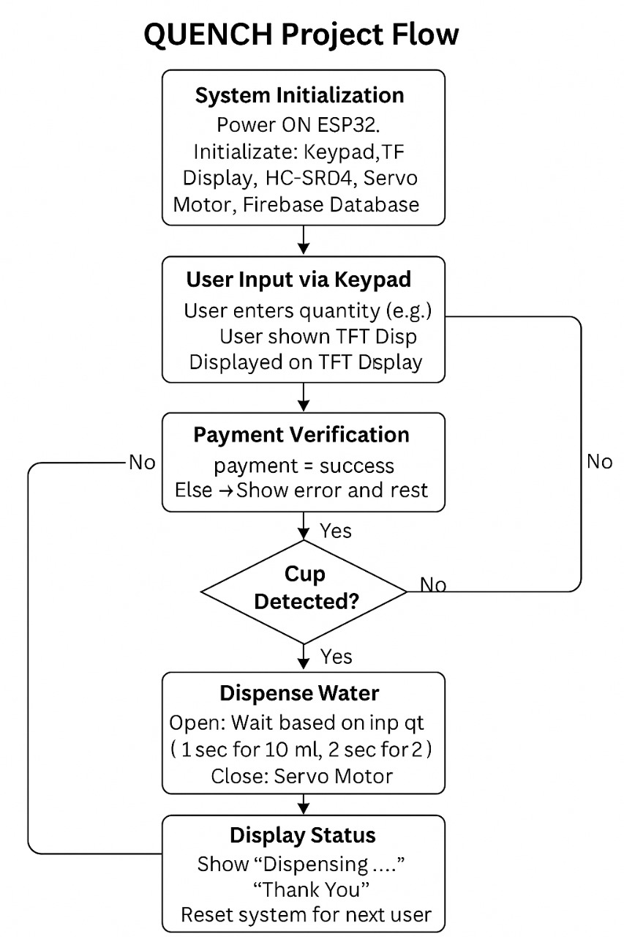
Figure III.1 Flowchart of the ESP 32 Logic

Appendix IV

IoT Based Web Dashboard

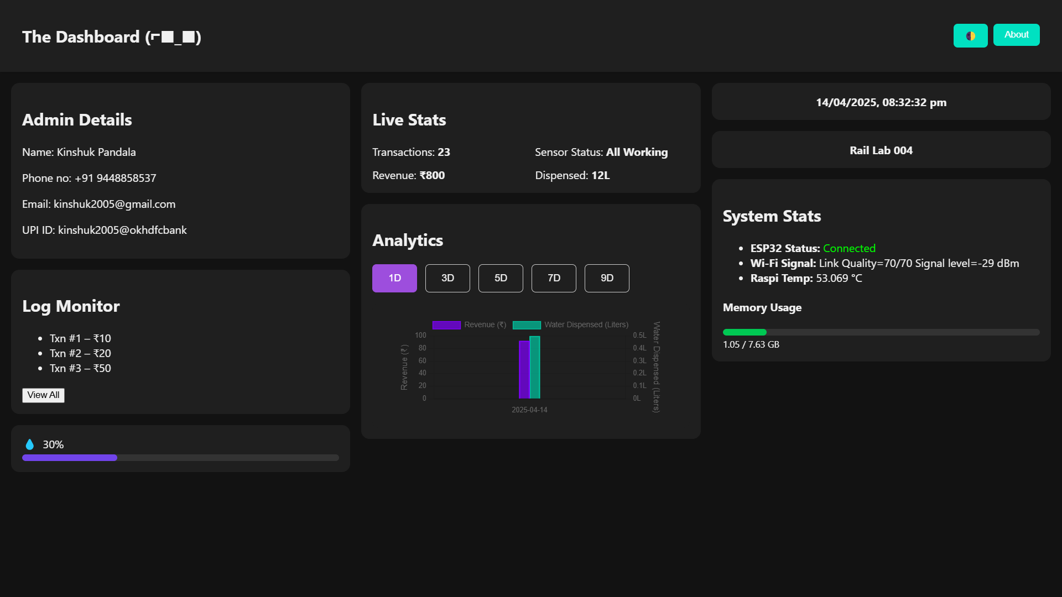
Figure IV.1 Iot Web Dashboard

